Week One Devotion
Revelations 1-22

Fire, smoke, terror, death.

Like scenes from a horror movie these are the images that most believers think of when they think about the 66th and Final Book of the Bible, Revelations. Many will never read it all the way through because of the heaviness and finality of its pages. And this is exactly the plan of the enemy!

Although it is true that Revelations brings us the true prophecies of the End Times we must remember that the term “End Times” does not mean the end for those who put their faith and trust in Jesus Christ as Savior.
Scripture tells us “that ALL scripture is God-breathed (truth) and useful for teaching”. We must understand the Revelation stands as both a measuring line of righteousness for our lives and our church. It gives us valuable information that we can use to motivate and warn others of the coming judgement. It gives us beautiful and powerful promises of God’s protection and empowerment through the blood of Christ and the baptism of the Holy Spirit.

In one of the most unique moments of the New Testament Jesus pens seven letters to the seven major churches at that moment in history, giving each insight, warning, and encouragement. Because of God’s omniscience or in layman’s terms- His All Knowing nature, He is able to speak to the real life issues they were facing then, and the real life issues we are facing in our present day. Chapter one gives us one of the least known promises of double blessing in the Bible when Jesus declares that first; those that read the words of this book will be blessed, and secondly those that heed the words of this book will be blessed. What a promise!

As we begin this journey into Revelations let read and heed its words, and walk victoriously towards His blessing!

Pastor Steve Stewart
Stay Connected and Receive New Devotions, Listen to Seven Letters Sermons and get Bonus Challenges by checking our website or social media daily!
Go to www.sanctuarychurchofgod.org and
Click on Seven Letters Image
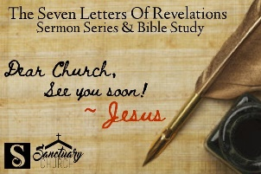

On Facebook search “The Sanctuary Church of God”
On Twitter @ SCOGCHURCH

