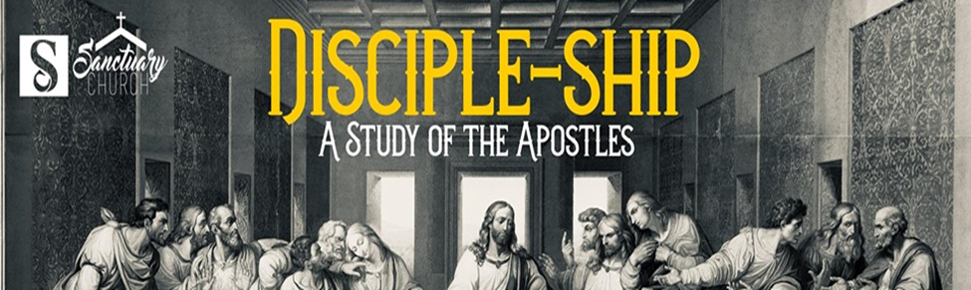

Disciple-Ship
Week 10

Disciple Focus: Philip
Tonight’s Text: John 12:26 New Living Translation (NLT)
²⁶ Anyone who wants to serve me must follow me, because my servants must be where I am. And the Father will honor anyone who serves me.

What’s in a name?
Philip the Apostle was from Bethsaida, a town in Galilee (John 1:43; John 12:21). He was one of the original twelve apostles of Jesus (Matt.10:3; Mark 3:18; Luke 6:14). He was mentioned in the Synoptic Gospels, but the Gospel of John offered a more detailed account of Philip’s involvement in Jesus’ ministry than the first three gospels. After Jesus had called Philip to follow him, he went to find his friend Nathanael and brought the initially skeptical man to Jesus (John 1:43-48). Philip and Andrew also stood out among the apostles as the only two men who had Greek names.

What does the bible tell us about Philip and his ministry?
Unlike some of the other disciples, we see Philip prominently mentioned throughout the Gospels and the Acts. Philip was a true servant; he immediately began telling people about Christ after his own conversion and could always be found working for the Lord. Scripture allows us to see Philip as a real person who is asked to do extraordinary things. Probably most notable was his reaction to Jesus’ command to feed the 5000. “Philip replied, “Even if we worked for months, we wouldn’t have enough money to feed them!” John 6:7. A close second would be his encounter with an Ethiopian Eunuch in Acts 8. This scripture contains the only reference in the Bible to a human experiencing a miraculous transportation from one location to another.

Q. What is the major theme of the discipleship of Philip?
A. God can supernaturally empower us to do ministry.
So many people believe that they are not talented enough to accomplish something for the Lord. The truth is that the Holy Spirit can and will empower us to do the work of ministry. Acts 1:8- But you will receive power when the Holy Spirit comes upon you. And you will be my witnesses, telling people about me everywhere—in Jerusalem, throughout Judea, in Samaria, and to the ends of the earth.

Hard Truth: If you do not tell others about Jesus, you are not a disciple.

